Zomentum Hiring Assessment

Back end Solution

Name – Suyash verma

Enroll – 17103052

Jaypee Institute of Information Technology

Technology used – Flask

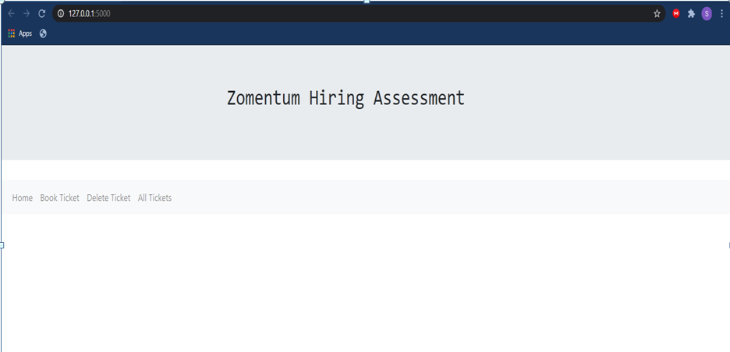

Book ticket

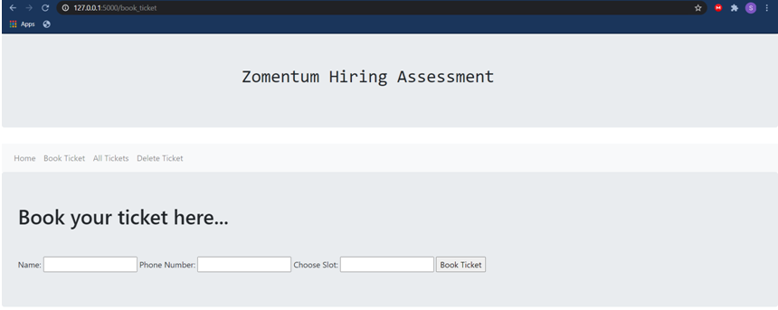

\*\*

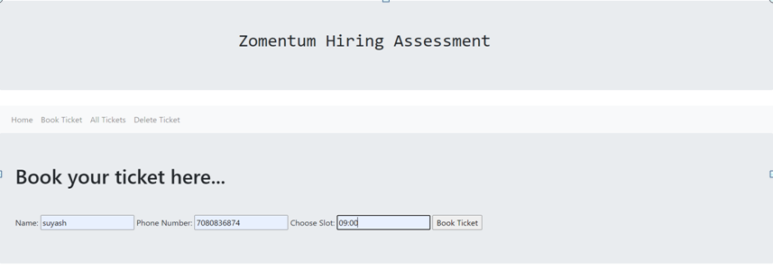

\*\*

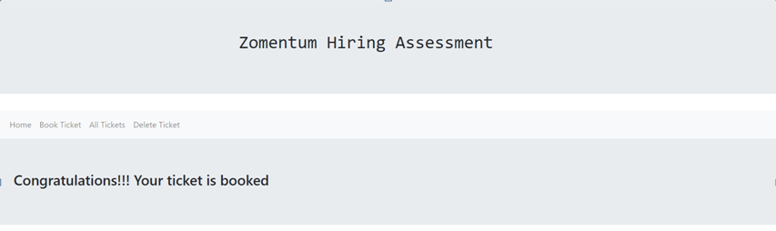

View all ticket booked

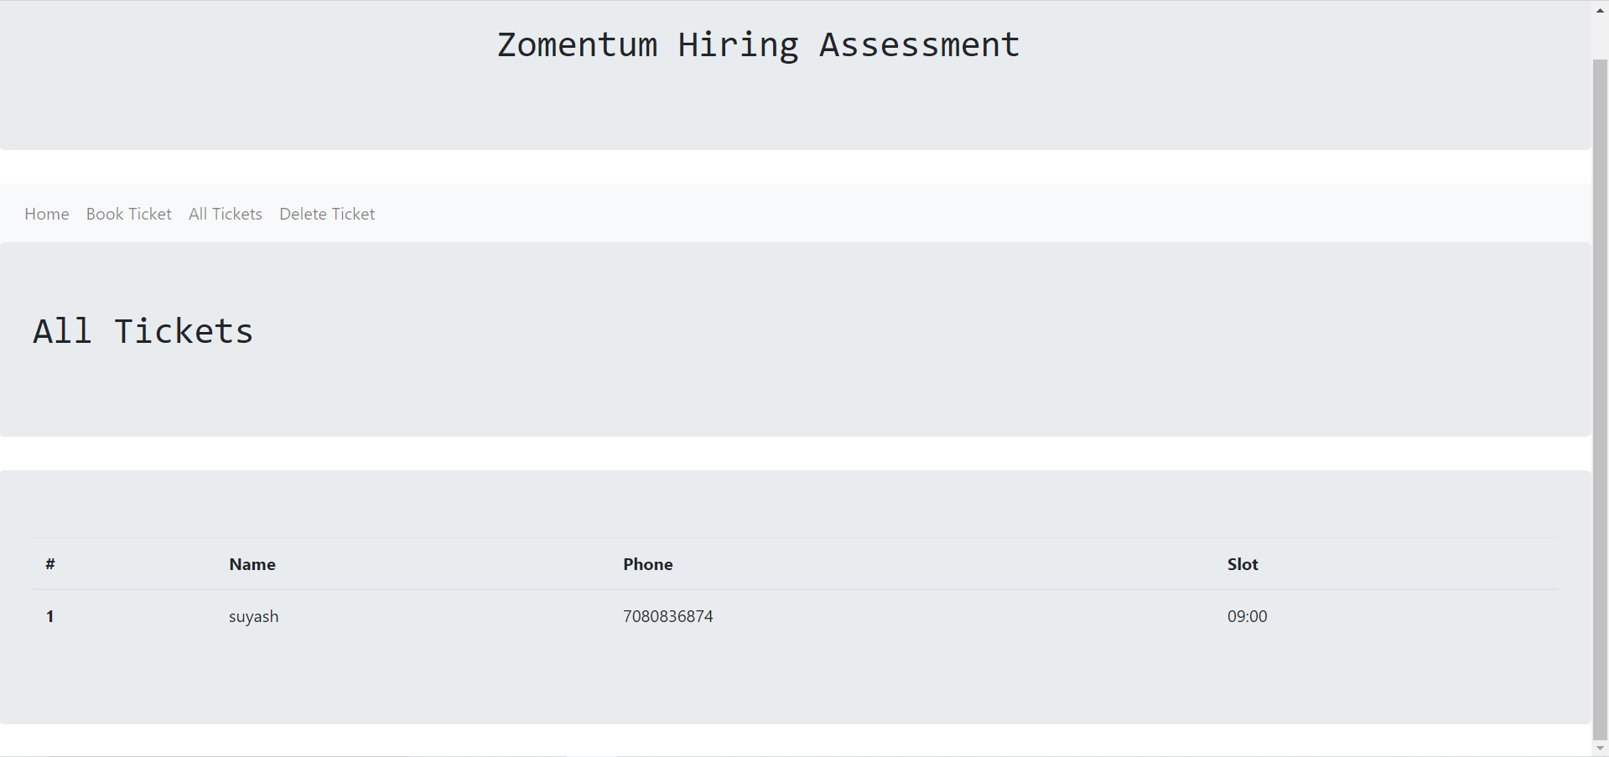

Enter total 20 entries and then try to add 21st entry

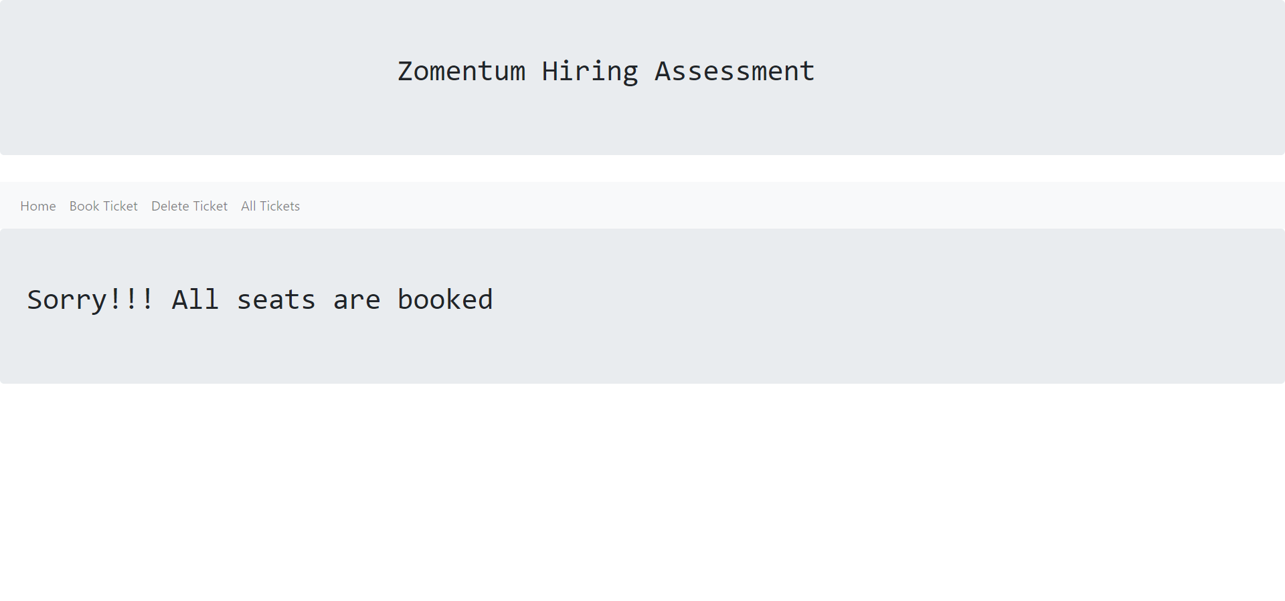

Delete ticket

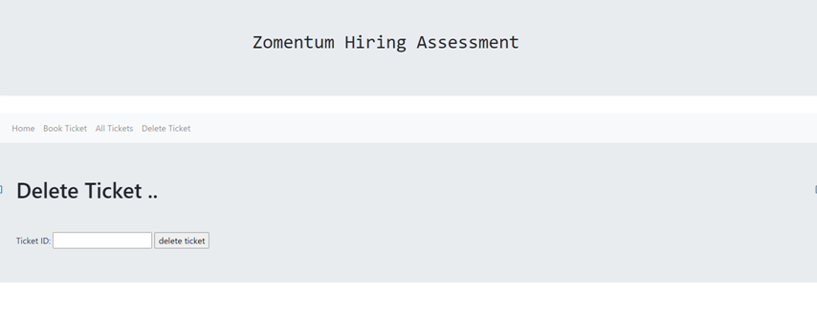

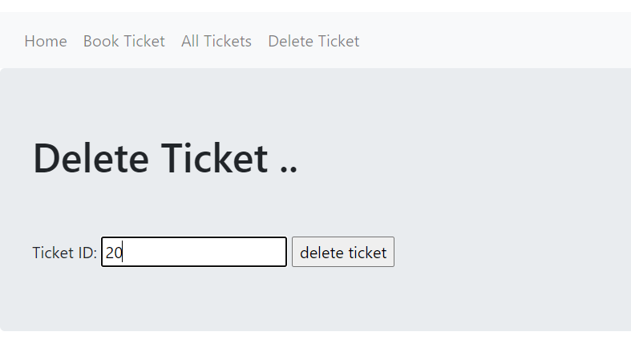

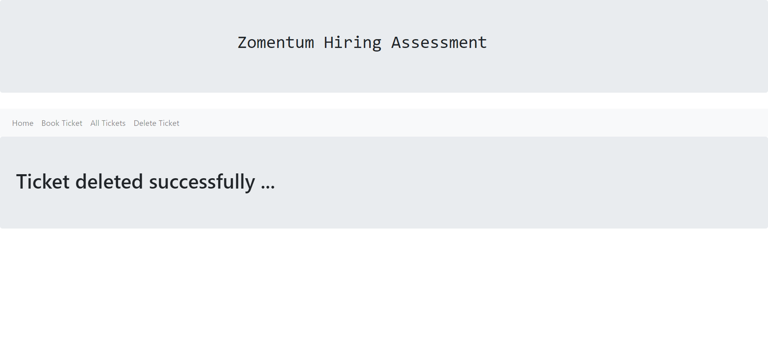

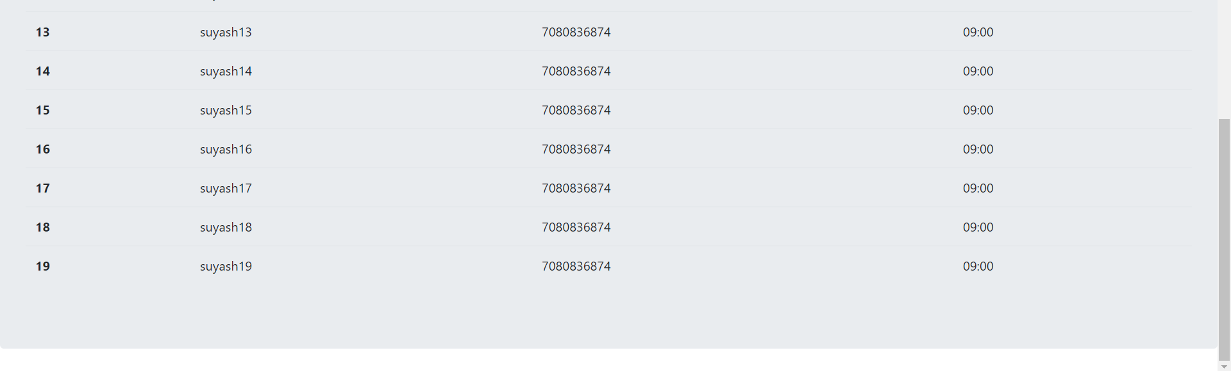

Ticket deleted.